Excel Addendum
Workbook 2 makes use of Excel’s ability to create charts, however, there are some differences if using an older version, such as Excel 2010 that is found in the student labs.
For example, section 2.2 introduced a series of charts to test the quality of the data.

Previous Updates
The following assumes you have renamed the worksheet with the reshaped data to:
Resident_Pay
And the column headings to Authority, Year and Pay. For example, the initial data looks like this:
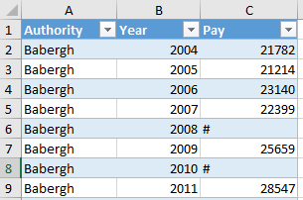

Babergh Charts
If your chart for Babergh looks more like this (section 2.2.1):

Rather than this:
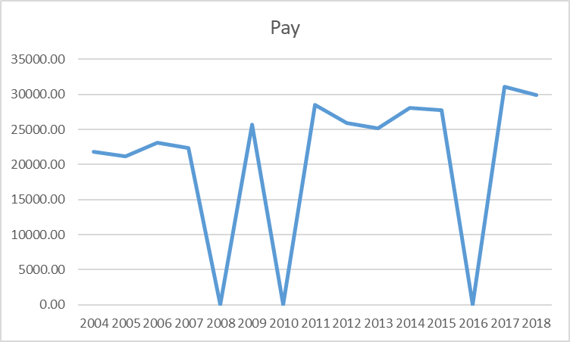
Then you need to follow the following steps. If the chart looks as expected, then you do not need to carry on with the following.

Selecting data
Select Babergh’s data as before, but now just select the Pay values (i.e., rows C2:C16), then click on Insert and pick Line: 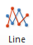 for a Line Chart, then pick the first 2-D line option from the list: 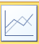
This will produce a chart like this:

Which is now the right shape, but is missing the correct x-axis (horizontal) values and should have a more meaningful name for the series.

Chart Amendments
To make changes, right click on the chart and pick Select Data… from the options.
This will bring up the following window:
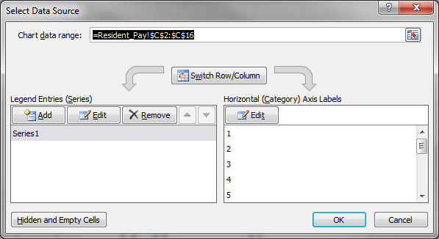
Next, click on the Edit button found under Legend Entries (Series)
In the Series Name box type in: Pay
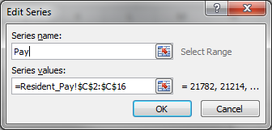
Press OK to accept.
Next, press the Edit button found under the Hortizontal (Category) Axis Labels
And select the Year values for Babergh, that is rows =Resident_Pay!$B$2:$B$16. If you use the mouse to select the rows from the worksheet they will show as:
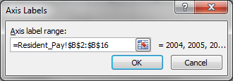
Click on OK to accept
The Select Data Source options will show as:
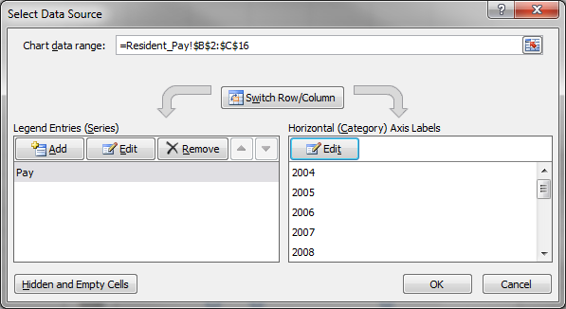
Press OK to accept
Our Chart now looks as expected:

Changing the Chart type to bar will keep these options, so if you click on the Chart and select the Change Chart Type found in the top menu: 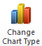 Changing the Chart Type to Column and the first option: 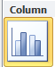
Will produce a bar chart as seen in Workbook 2:

Process for Excel 2010
You need to do the same process for any other set of values:
- Select the Pay values only (i.e., the values in column C)
- Use Insert>Chart Type to pick a particular type of chart, such as 2-D Column
- Right click on the chart and pick Select Data…
- Use the Edit on the left-hand side (Legend Entries (Series) to name the Series to something appropriate, Pay in this case.
- Use the Edit on the right-hand side (Horizontal (Category) Axis Labels) to pick the x-axis values, which are the Year values for this data, typically 2004-2018)
The chart should now look as seen in Workbook 2.

